# Recommendation Form For Admission to Kindergarten

**Name of Child: ISHANVI NEGI Applying to Grade: KG-1**

**The child's application cannot be processed until this form is received in our Office of Admissions.**

**Principal or Teacher:** Please complete this form and email it to the AISA Registrar's Office at admissions@aisa.sch.ae or send it in a sealed envelope to the school mailing address. This form will be treated with high confidentiality and will not be shared with the parents. Thank you for your time and cooperation.

**Parent**: I understand and agree that this reference form is confidential and will be used for the purpose of admissions assessment at AISA and will not be shared by anyone outside the Admissions Committee. I waive any right that I may have to see it.

**Signature of the Parent or Guardian**

13-May-2022

**Date**

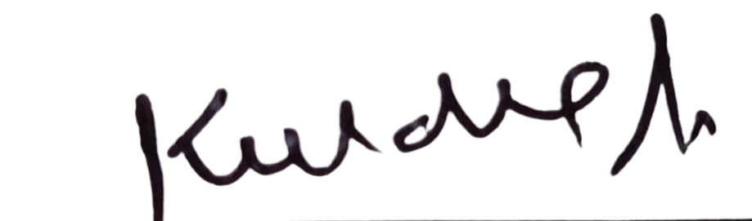

Check the child's developmental progress in the following areas:

|  |  |  |  |  |
| --- | --- | --- | --- | --- |
|  | Above Level | On Level | Below Level | Significant Concern |
| Cognitive Development |  |  |  |  |
| Emotional Development |  |  |  |  |
| Motor Development |  |  |  |  |
| Social Development |  |  |  |  |
| Speech & Language Development |  |  |  |  |
| Separation Issues |  |  |  |  |

Check the child’s performance of tasks:

|  |  |  |  |
| --- | --- | --- | --- |
|  | **Has Mastered** | **Developing** | **Not Yet** |
| Using Scissors |  |  |  |
| Using Crayons |  |  |  |
| Writing Own Name |  |  |  |
| Expressing Self |  |  |  |
| Assembling Puzzles |  |  |  |
| Looking at Books Independently |  |  |  |
| Recognize Basic Shapes |  |  |  |
| Can Count Numbers (1- 20) or more |  |  |  |



Check the child’s attitude and behavior:

|  |  |  |  |  |
| --- | --- | --- | --- | --- |
|  | **Very Good** | **Good** | **Needs Improvement** | **Unsatisfactory** |
| Attitude |  |  |  |  |
| Behavioral Management |  |  |  |  |
| Follows Directions/Completes Tasks |  |  |  |  |
| Attentive/Focused |  |  |  |  |
| Relationship With Peers |  |  |  |  |
| Relationship With Adults |  |  |  |  |

Please check Yes or No:

|  |  |  |
| --- | --- | --- |
|  | **Yes** | **No** |
| Does the child have any stories memorized that he/she can read to you? |  |  |
| Does the child pretend to read stories aloud to you? |  |  |
| Does the child need an Individual Education Plan (IEP)? |  |  |
| Has the child received extra support in school (ELL, special education)? |  |  |
| Has the child received speech therapy? |  |  |
| Has the child received occupational therapy? |  |  |
| Has the child seen any outside specialist? |  |  |

Is there any diagnostic testing evaluation or results for this child that you are aware of? If so please

give details



Are there any special strategies or interventions you recommend be used with this child? If so please give details



How would you describe the parents' role in their child's education and their support of your school's policies and rules? _______________________________________________________________



**Name**: **Title**:

**School**: **Email Address: Date: Signature:**

**Please add the school Stamp.**